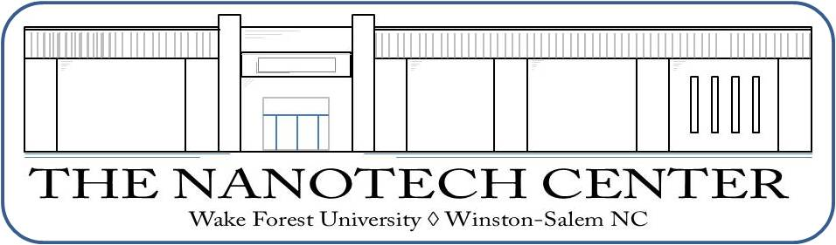
Center for Nanotechnology and Molecular Materials
at Wake Forest University

2010-2011 activities report

This report contains a summary of the activities of the Center for Nanotechnology and Molecular Materials at Wake Forest University for the 20102011 academic year. The document was prepared by Dr. David Carroll, Center director and circulated among the 12 Center affiliates for approval before submission.
Contents…

Educational initiatives
Continuing and new funding
Funding requests
Publications
Patents
Conferences
Outreach
Notable accomplishments

