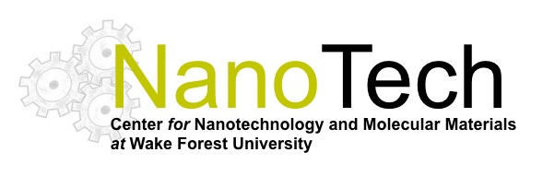

Report of Activities (ROA) for Center for Nanotechnology and Molecular Materials

Performance period: AY: 2013 – 2014
Prepared and submitted by: David Carroll (Director)

Operational Budget: $50,000.00 WFU
$ X,XXX.XX Indirect recovery

Members: Oana Jurchescu (Physics)
Richard Williams (Physics)
David Carroll (Physics)
Abdou Lachgar (Chemistry)
Ravi Singh (Caner Biology)
Thomas Smith (Orthopaedics)
Beth Smith (Orthopaedics)
Nicole Levi-Polychenko (Plastic Surgery)
Aaron Mohs (BME)
XX XX (BME)

Statement of Three Operational Principles:

- Provide infrastructural resources for the WFU research and Educational community in nanoscience.
- Establish a bridge between traditional research disciplines and the nanosciences for the WFU community.
- Establish world recognized research in the nanosciences at WFU.

Contents:

- Facilities and Assets
- Research Highlights
- Educational Highlights
- Outreach
- Synergisms

Introduction

- Facilities and Assets
- Research Highlights
- Educational Highlights
- Outreach
- Synergisms

Carroll, Williams – WP submitted to AFOSR on Excited State Engineering
Jurchescu, Williams, Carroll, Electron Beam Deposition system from NSF
Levi, Carroll, Nano-Mentorship Proposal to NIH
Smith, Carroll WP to Army on pressure sensors

Numerous proposal submissions were supported committing access to facilities.

