End of Year Report
2021-2022

Submitted To:
Keith Bonin
Vice Provost for Research and Scholarly Inquiry
Wake Forest University

Submitted By:
Center for Nanotechnology and Molecular Materials
at Wake Forest University (NANOTECH)

David Carroll, PhD
Center Director

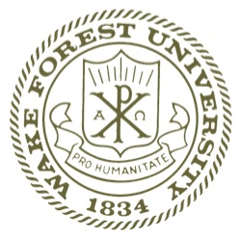

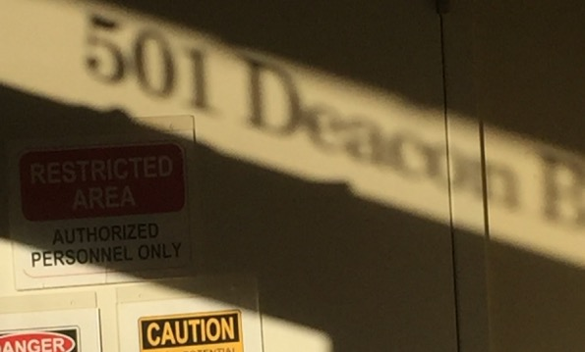

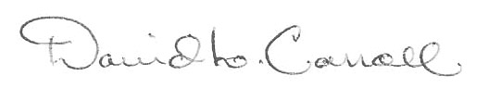
Compiled by:
Overview

This document contains an overview and summary of activities at the NANOTECH Center for the 2021-2022 academic year. These activities fall into one of four strategic categories:

- Facilities and capabilities enhancement for the research community,
- Academic products and educational opportunities centered on Nanotechnology scholarship,
- Community support activities,
- Outreach and diversity

It should be realized that as a user facility such a broad range of “research center” activities is unusual. There are no PI teams with centralized funding and multiple layers of administration. Instead, there are user groups which turn to the center for equipment, support, enrichment, and colleagueship. This structure comes from NANOTECH’s unique charter that recognized early on that for our mission during this time of national and international growth in WFU’s history, it is not enough just to let current researchers use some equipment. Instead, the decision was taken to build a multidisciplinary community of research around emerging areas of opportunities in scholarship. To do this requires unique capabilities, outreach, community support and broadening of our community to a more diverse group of researchers.

Thus, the core strategic categories of activities were developed. Each year multiple user groups (referred to as center members) have participated in all of these categories regularly, on a voluntary basis. The success in community growth around the center as well as impacts on undergraduate and graduate research has been well documented over the years. Our facilities capabilities are on par with those of Duke, Vanderbilt, Brown, Tufts, Emory, Boston College, and Dartmouth. Our outreach programs teach on site researchers as well as non-WFU affiliates how to use the facilities and how to advance their own research with new techniques. Educational efforts offer subject specific courses that are typically found at only the largest R1 research institutes. And while attempts at diversity enhancement have remained behind our peers with respect to minorities, we have exceeded many of them in providing access to women in science and technical fields.

- Successes

A hallmark of the Center support system is the introduction of new initiatives based on the potential growth of Center impact with existing WFU programmatics. This year is no different with the initiation of Quantum Computing as a major thrust area. Conceptually this initiative integrates faculty from computer science, physics, chemistry and engineering yielding a community forum for the expression of interests and new scholarship in this exciting new arena. This year the Center has won several new awards in the field, hosted two intercollege discussion groups and talks, developed a full course in the essentials of Quantum Computing which even included a number of off-site, online participants, enhanced our cleanroom infrastructure to build the circuits of a quantum machine and characterize them, and established collaborations with two important European labs in the field. The growth in WFU’s competitiveness in quantum computing has been exponential.

Significant achievements in capabilities

1st 365 nm i-line lithography demonstrated using Nanotech tool set

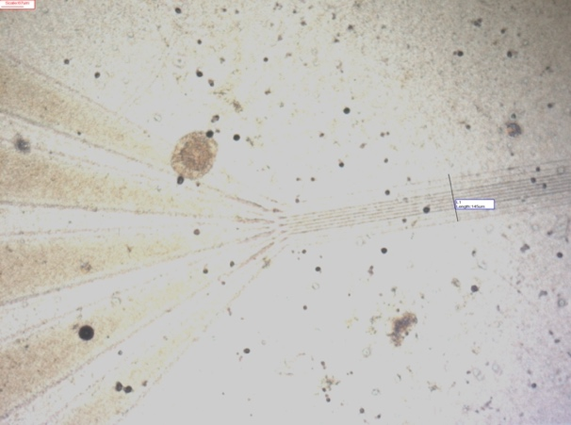
The white bar is about 10 microns. There are 10 control lines running through the line drawn out onto the widening control pads. The spots seen is because this image was taken before ashing and the liftoff hasn’t fully been removed. This is an optical image captured with the cleanroom Olympus X60 metallographic camera. A Pd binding layer with Au contact layer is used over a thermally grown SiO₂ film that is 20 nm thick. The substrate is B-doped Si.

1st direct measurement of differential conductivity in a CP protected topological state on a 2D Qubit along with direct imaging of that state at room temperature. The image below shows the states as contrast enhancements along the perimeter.

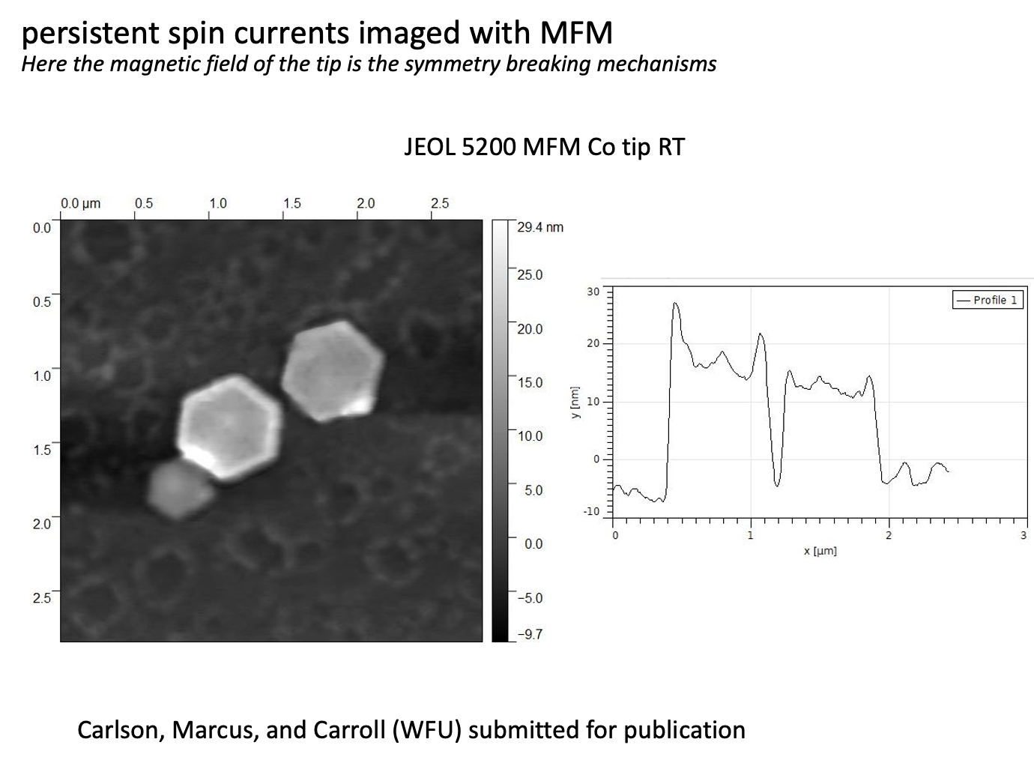
Below is show the circuit and Qubit setup for measurement of conductivity and differential conductivity of the Qubit. This work was done as a result of AFOSR funding and has been repeated by our collaborators in Germany Erlangen (FAU).
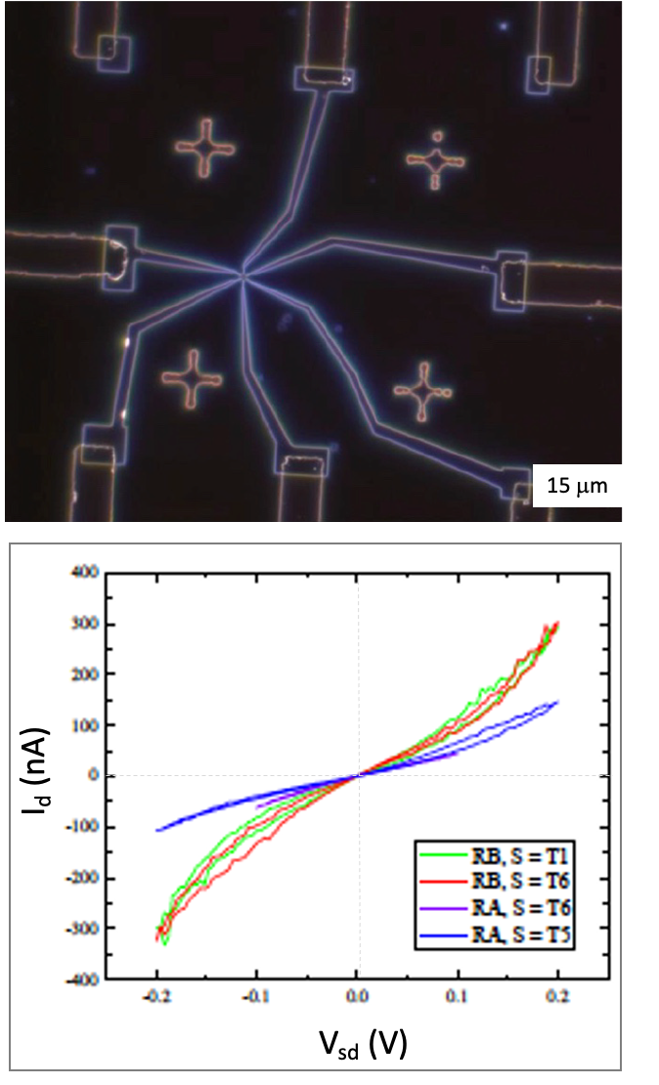

Work on the new ARPES system has begun in earnest. This system will be a laser driven 7 eV UHV system capable of full surface analysis and crystal orientation (no relative measurements).

A new SEM has been identified for adding ebeam lithography which will carry our linewidths down to 30 nm or less. We hope to have this in place by the end of summer.

Research/Scholarship/Creative Works Publications NANOTECH
(affiliates and members do not report papers typically)

Solvothermal Growth of Moiré Superlattices in Antimony Telluride Spiral-Type Nanoplates, 963775, Robert Link, Gabriel Marcus and David Loren Carroll, Frontiers in Materials, section Quantum Materials Submitted on: 07 Jun 2022 (accepted July 2)

Modulation of recombination zone position for white perovskite/organic emitter hybrid light-emitting devices X Zhang, X Yan, LJ Gray, J Xu, W Xie, DL Carroll Applied Physics Letters 120 (9), 093301 2022

Correction: Synthesis of lead-free Cs 3 Sb 2 Br 9 perovskite alternative nanocrystals with enhanced photocatalytic CO 2 reduction activity C Lu, DS Itanze, AG Aragon, X Ma, H Li, KB Ucer, C Hewitt, DL Carroll, ..., Nanoscale 2022

Toward Perovskite-Related Scintillators with Necessary Stokes Shift and Thickness for Hard X-Ray Radiography and Gamma Spectroscopy WW Wolszczak, DL Carroll, RT Williams Advanced X-ray Detector Technologies, 1-34 1 2022

Mapping and distribution of speciation changes of metals from nanoparticles in environmental matrices using synchrotron radiation techniques G Chandrakasan, MT Ayala, JFG Trejo, G Marcus, DL Carroll Environmental Nanotechnology, Monitoring & Management 16, 100491 3 2021

Passive tracking and combined photovoltaics with solar-thermal capture using simple 3D optical structures LJ Gray, C Griffin, W Wolszczak, P Allaire, DL Carroll Journal of Renewable and Sustainable Energy 13 (6), 069101 2021

Binary and Ternary Colloidal Cu‐Sn‐Te Nanocrystals for Thermoelectric Thin Films
D Yin, C Dun, H Zhang, Z Fu, X Gao, X Wang, DJ Singh, DL Carroll, Y Liu, ... Small 17 (11), 2006729 5 2021

A Novel Type of Water Desalination Technology Using MoS2-Based Thin Films for Selective Ion Transport G Marcus, D Carroll LJ Gray, DL Carroll, S Roth Graphene, 439-457 2021

The rise of graphene in carbon thermoelectrics
DL Carroll, S Roth, G Marcus Graphene, 143-174 2021

Introduction to physics of low-dimensional systems
S Roth, DL Carroll Graphene, 1-12 2021

Since our affiliates and members are not required to put NANOTECH on their byline, nor do they report to us the total of their yearly publications, a simple poll was done to estimate overall publication impact. From that poll an additional 20 publications across the university could attribute aid from NANOTECH.

Creative works staged/facilitated

In the 2022/2021 year NANOTECH served researcher from 12 groups across the campuses for a total of approximately 40 researchers. Significant external users is approximately 6 researchers. The graph below shows time allocation for the different user fields. WFU indicates affiliates of the university that are not members of the centers user groups.

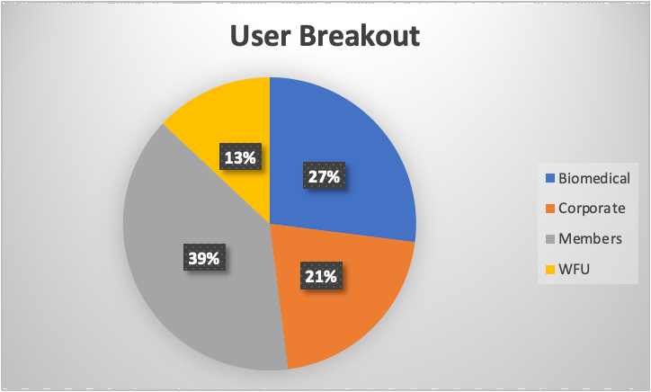

Tools usage weighs heavily toward microscopy though this does include more exotic microscopes like MFM. Cleanroom usage was down due to air handler problems which reduced its overall “up-time.” These have now been corrected but it took sev3rla months for new parts to arrive. Similarly, XPS was down for a significant part of the work year.

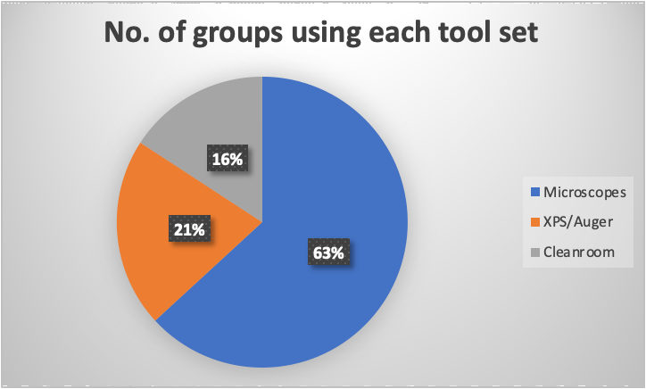

Creative works Outreach

The NANOTECH Center sponsors a summer intern program to encourage students from undergraduate colleges and high schools to engage in science and as a tool to recruit to WFU programs. These projects include:

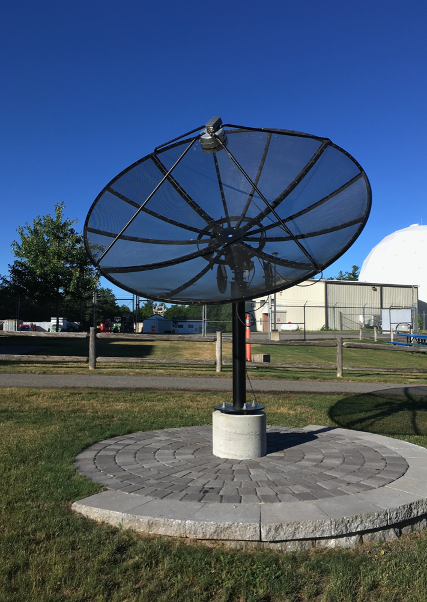
- The first fully functioning, mapping small radio telescope at WFU. Done in conjunction with the Astrophysics group at WFU a modified and improved version of the SRT from MIT’s haystack observatories has been built.

The R. Brehme SRT has 5º resolution scanning and is capable of mapping most of the northern sky. It is tuned to the 21 cm line (1.4 GHz) with first signals being detected earlier this summer. A control system has already been developed to make the telescope accessible to Astronomy labs at Olin from its base at NANOTECH. We are current improving its mapping capabilities (backlash) and sensitivity while also developing several lab exercises for the school. The digital signal is timed to that it can be linked with other SRTs in the south to form an interferometer. The website will be up shortly.

2. Biobatteries based on implantable self -regenerating thermoelectrics. This work is carried out in conjunction with Regen. Medicine and is intended to replace the bulky systems we use today for pacemakers and other auto-injectable systems

3. Thermal batteries is a project being carried out in conjunction with Ford Motor Company and is in conjunction with the department of physics as well as engineering. Based on new battery designed, waste heat is used to enhance ion flow through the separator membrane of a Li-ion cell. Ideally this is equivalent to a 30% increase in power density and a 40% increase in specific density.

Conferences/workshops/meetings/talks organized

The NANOTECH Center sponsored 4 intercollege workshops to aid in teaming efforts for funding opportunities. These included a series of talks from outside experts, advice from an NSF program manager, and detailed discussions about recent work done on the WFU campus.

All other international conference we usually sponsor were postpone due to COVID.
Financial Sustainability

Grants/contracts
(We only track successful applications)

AFOSR $125,000 SBIR phase 11
AFOSR $ 300,000 STTR phase 11

Funding from foundations and/or corporate sources

$100,000 Streamline LLC

Number of companies started/patents filed

Quoherent LLC was started this past performance period with four principles. Alton Reich is the president. Dr. Carroll is technical adviser as part of the license deal signed with WFU. They have licensed 4 patent families from WFU.

Thin-film PN junctions and applications thereof
D Carroll
US Patent 11,101,439 2021

Thermoelectric Apparatus And Applications Thereof
DL Carroll
US Patent App. 17/115,121 2021

Thin-film pn junctions and applications thereof
D Carroll
US Patent App. 17/388,210 2021

Perovskite lighting systems
D Carroll, J Xu
US Patent App. 17/285,762 1 2021

ION separation media and applications thereof
DL Carroll
US Patent 11,278,863 2022

Number of faculty involved

See above

Student engagement

20 different graduate students and 5 undergraduates were engaged in work at NANOTECH this year.

Curricular: new majors/minors, programs, courses

NANOTECH holds a sequence of classes for graduate students and senior undergraduates. This year this included electron microscopy, exotic materials, and a new course Quantum Computing.

Center or Institute Goals and Objectives

Goals

Our goals this past year depended deeply on the state of the pandemic.

Goal 1: At a minimum we wanted to achieve I line lithography and first measurements of our Qubits. The tools for these tasks needed to be added and we did achieve this.

Goal 2: We wanted to increase participation at NANOTECH. We did increase collaboration for a number of members but not user numbers.

Goal 3: We wanted to submit one large multi-investigator type proposal (along with our usual cadre of smaller proposals) to a major funding source like NSF. This was in fact well underway until our WFU PI (without explanation) pulled out. The team has been reformed and we will try for the call again next year.

Goal 4: We sought at least one license event and this was achieved.

What are the key goals for the upcoming year?

Goal 1: A large multi-investigator proposal submission that exceeds 1M/year. To achieve this we have already put into place a team and have begun having writing meetings. A program manager at NSF has agreed to aid us in targeting the divisions and contacts we need.

Goal 2: An increase in RAs. To achieve this we must be successful in grant writing. This has already begun to come to pass with the $300,000 AFOSR grant. We have also learned we have been selected for a large Quantum Computing Award early in the next FY. The key has been investment of time with agencies discussing new developments in our labs.

Goal 3: Increase the intercollege workshops to generate more excitement and community around what we do well. This was a huge success this year and many have asked us to expand, so we will. Dr. Carroll has already discussed dates with key user groups and we intend to have 3 of these per semester.

Goal 4: Enhance lithography capabilities and improve microscopy. To do this we will rely on donations sought by team members for slightly used equipment from decommissioned sites. Specifically in e-beam lithography. Our hope is that we will raise the money through AFOSR to purchase a new FIB system. Finally we are adding new capabilities to our STEM with money we have already set aside from indirects.

Detail your planned expenses for the coming year

For the coming year our University granted budget will be used on maintenance for the 2010 and its instrument packs. Upgrades to the JEOL 6330 will also be made. This is approximately 65% of our funding. Supplies for the instruments and filters for the cleanroom are another 15%. Finally we will supplement one part time RA as a part time microscopy tutor and maintenance person (as a replacement for Corey our previous staff tech). To cover all of this will take the total sum of the University funds plus the funds from the indirect of the current funding.

Assessment activities

This year NANOTECH is due for another external review of our programs. This will involve several site visitors and a report being generated for the University. The committee will be composed of ad hoc reviewers from our board, and who have the time and have agreed to act in this capacity. Visitors are local so travel costs are minimum. Reviewers from overseas will be addressed via Zoom conferencing. We plan on using a basic question outline from NSF used on site visits to MRSECs. This will have an addendum of questions to be asked generated from user groups, admin. and any other university affiliate that wishes to be heard. The final set of questions will be decided by the operations group of the center - all the user group heads. If requested the results of this review can be presented to the Vice provost of research or simply delivered as a report. This is in accord with our first MOU with the University and traditions of the Center.

Personal Assessments

- Strengths/Weaknesses, What is your assessment of the overall strengths and weaknesses of your Center/Institute in teaching, research, and service (one page)?

The model for a service center at a small university can be challenging. This challenge is compounded when the University is in a phase of its history that can take it into international recognition for its scholarship. There are many on our campus that believe in the cause of scholarship as a primary pillar on which Universities in general and WFU in specific are founded. You will find many of those believers at the NANOTECH Center on a weekly basis. This willingness to go beyond our calling, to build as part of our career paths, and to dedicate ourselves to a task that we will not see completed is truly unique at Wake and I believe that the Center gives them a home. That is our success. Aside from the excellent equipment and capabilities we have gathered, aside from the publication record and appearance in international press, etc. What we have really done is to build a community that teaches our graduate students, does our research, and believes in an impact as though we were at Stanford. We are finding the cures for mankind’s ills, while setting the stage for greater cures yet to come from this campus.

But, Wake Forest is of two minds, and there are only a few departments with faculty willing to join us. The culture, time frames and commitment of non PhD granting departments (not counting the arts) is simply different. The NANOTECH centers greatest failure is that we have not been able to communicate with this mind of our University effectively. Forays by our faculty into engineering and computer science have met with some success, but these are tentative steps and they take more patience than many of us have the time to show to our own discredit. Moreover, I said we teach our students as though they were at Stanford, and indeed WFU graduate students have fared quite well in the “real world.” The last four from NANOTECH went to Stanford, Stanford, Berkeley, and Los Alamos National Labs. They all have publications in Nature and Science and Wanyi at LANL is considered one of the worlds experts in perovskite solar while Chaochao has worked with Nobel Laureates. Yet we, as an institution, do not laud these accomplishments at the very top of our field. This is simply because University journalists (many of whom graduate from WFU) do not take physics classes. In fact, I actually had someone from our media department tell me that they had not realized we even had graduate programs. (this isn’t surprising, I was at NCSU and I didn’t realize we had them there either)

However, the really great thing about Wake is that Wake lets you believe in anything you want to believe in. It lets you try anything you want to try – as long as you don’t embarrass the school. And so all these things can be fixed. Our failing is that we have not found that formula and this was a primary reason the Center was founded. It is our goal to show Wake that it does belong in the top 30 – or top 20 even - of the rankings, and not just for its undergraduate teaching, but for its scholarship. Other small schools have done it: Rice, Dartmouth, Brown, Vanderbilt to name a few. When we find the magic potion for this, we will have done what we set out to do, to build a university that matters to everyone, to the local economy and to the national pride.

- Comment on how other offices and services of the University can be improved to assist in supporting the work of your faculty and staff and in achieving your goals.

I have no comment on this. They simply could not be better. I have here more support than most of my colleagues with a fraction of the politics. Achieving our goals is up to us at NANOTECH, it is why you hired us. We have no better leader than Keith Bonin (who keeps us all on the straight and narrow) and the teams that handle accounting and services consistently go out of their way to help when we ask. I feel this way because I have taught at other institutions and I know the pitfalls. Yes, we could have more support for large equipment purchases, but we are just getting around to this. We could have better patent portfolio management, but we are learning. Wake never stands still and I have never been disappointed. I say just let her grow, she will do alright. BTW since coming here I have had 5 hard offers to leave, more money, more “support”, more more. I never even came close to considering it. In the NANOTECH group, I am not the only one.

- Comment on efforts to make your Center/Institute a) more inclusive and b) more global in its orientation.

This is two questions, and I will start with the first naturally. We have failed miserably with inclusivity and diversity. We do have recruiting drives through the center all the time for underrepresented groups across the city and surroundings communities. But we never see any uptick in scientists of color. The answer here is to utilize the resources of the school more effectively than we have up until now. We simply have not been as serious about this as we should. The only bright spot in this is women in our graduate pool. We have produced about 35% female PhD graduates out of NANOTECH. It isn’t great but better than some and probably stems from our ties to the medical school where ratios are better. You will note that this is one of our goals for the upcoming year, to interact more effectively with such recruiting and retention efforts.

The second question is an interesting one as well. We are far better known and recognized across the world than we are here in Winston. We founded and continue to organize international meetings in Germany on topological systems, we have exchange programs with Germany and with Ireland, wherein their students come here to learn for a year and we send students there. We have a visiting scholar program where senior scientists from across the world visit with us and work side by side. We are also members of several European networks for research that share equipment and ideas on a regular basis and meet as an integrated team. Indeed our guests list from just the past few years boasts more than 20 different flags. NSF recognizes the Center as a major hub of activity as does DOE. Our scientists sit on review panels in various countries including the centralized funding agencies in Brussels. We even have a summertime study abroad effort with institutions in Germany and Austria for our undergraduates who sometimes find themselves locked out of the normal overseas experience because of curricular demands. NANOTECH could hardly be more international.

In Summary

We have done a lot over the past few years. We have built a community with an enviable reputation to judge from impact factors, h-factors, appointments to fellowships and more. We do not get students that are as well prepared as those of Cal Tech, but we make them competitive and important parts of the scientific community. Our equipment capabilities, research prowess, and output can stand up against most of our peers. But we still have a long way to go. We do not speak to our whole campus, we do not speak to a missing segment of our population, and we are not providing the solutions needed to take us and WFU to another level. This has nothing to do with WFU. Its support has been excellent. It is simply the growing pains of a Center trying to figure things out at a University that is growing along with us.

In the coming years we will see names change and new foci, new leadership and new ideas at NANOTECH. We will achieve that illusive Center grant from NSF (they already know we are here and hunting). And we will do it with a diverse and equitable group of scientists committed to the purposes of a great University. The question is: have we done enough to set the foundations for these things and these people to come?” My answer is: not yet. But I hope that this year’s report shows that we stay committed to doing so.

With Respect from the NANOTECH team of users and affiliates

END

